Best ARIMA order (v2): (1, 1, 0) CV MAPE: 15.863673794630307
Best GRU v2 cfg: {'units1': 160, 'units2': 96, 'dropout': 0.25, 'window': 28} val_loss: 0.12861500680446625

=== HOLDOUT (28d) RESULTS — v2 aggressive ===
MAE: 317.89
RMSE: 411.40
MAPE: 10.60%
Accuracy (1-MAPE): 89.40%
ARIMA-only MAPE: 14.98% → ΔMAPE vs Hybrid: +4.38 pts
gamma=1.079, alpha=0.000, beta=112.949
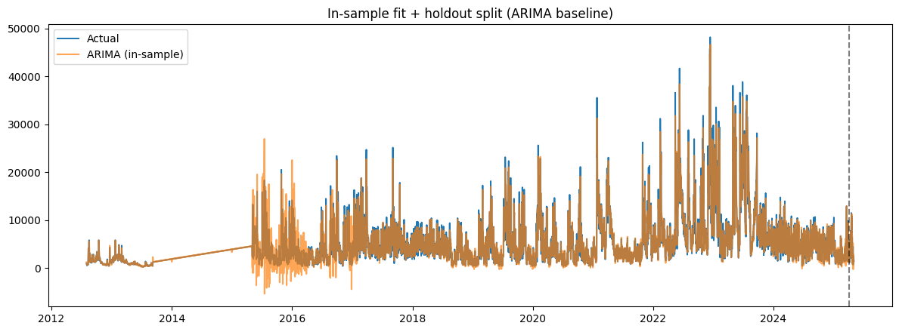
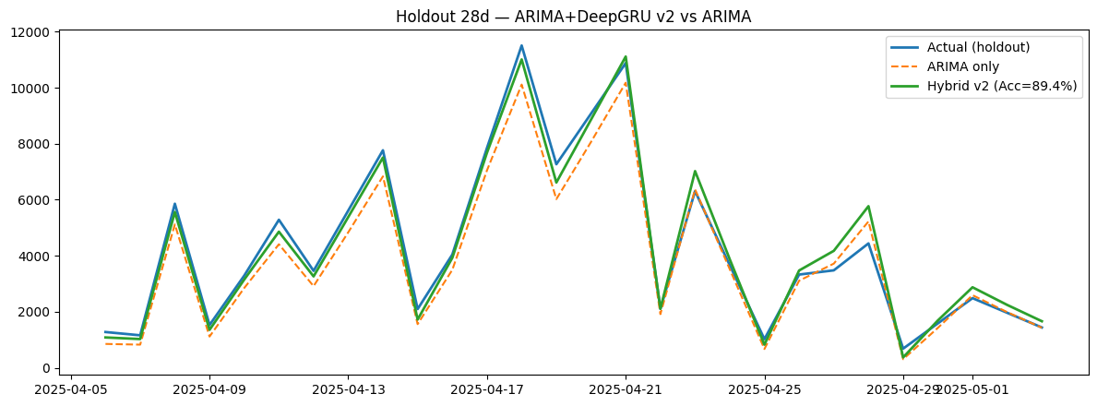
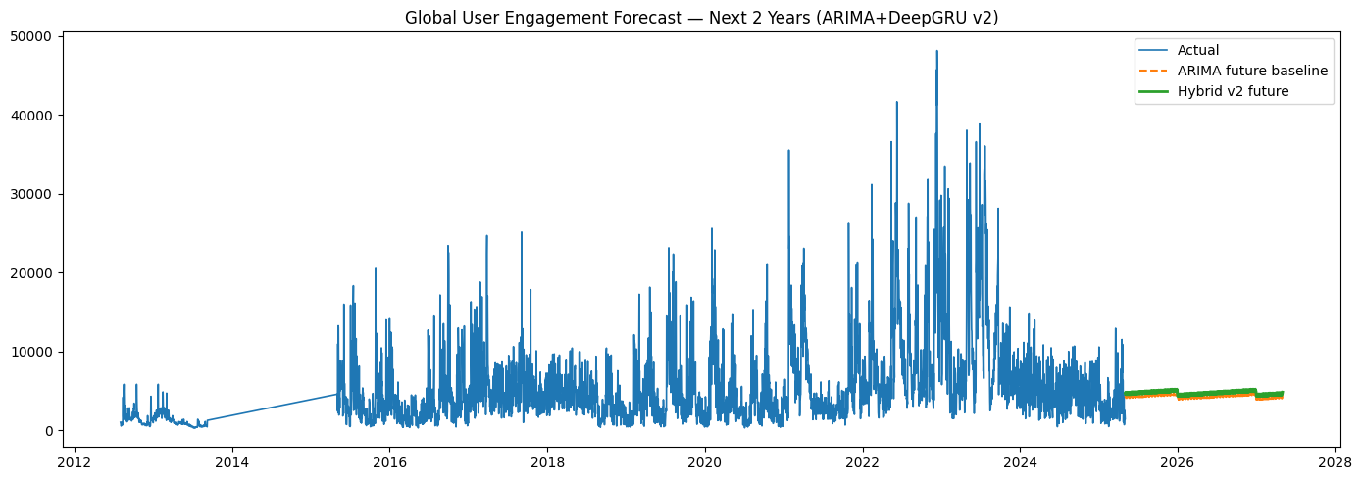

Artifacts: /content/hybrid_arima_gru_v2_artifacts
- 2year_forecast_arima_gru_v2.csv
- arima_order_v2.json
- arima_v2_model.pkl
- gru_v2_residual.keras
- metrics_arima_gru_v2.json
- x_scaler_v2.npy
- y_scaler_v2.npy

Checkpoints: /content/arima_gru_v2_ckpts
- gru_v2_best_win21.keras
- gru_v2_best_win28.keras

